SOMNIFERES

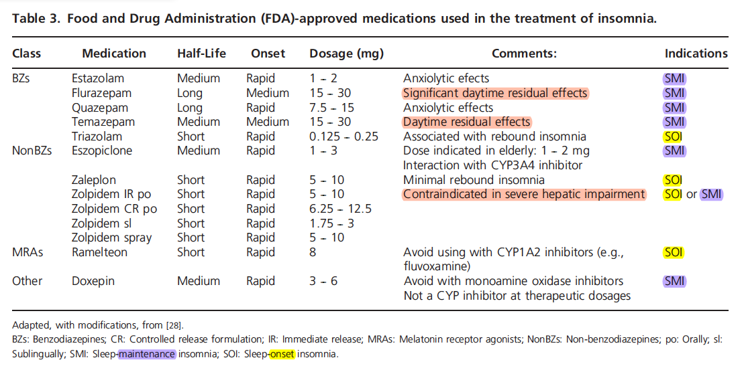
Expert Opin. Pharmacother. (2012) 13(9):1243-1260

